

**USER MANUAL SIGN-OFF**

**Authorization Memorandum**

This form is to sign-off completion of the Design Phase for **CAMPUS MANAGEMENT SOFTWARE AT WORLD SKILL CENTER (WSC).**

World Skill Centre (WSC) acknowledges receipt of the deliverables as part of the Design Phase through the submission of this document.

|  |  |
| --- | --- |
| **MODULE NAME** | Project Plan Monitoring |
| **MODULE OWNER** | Mr. Sanjay Padhi |

**WSC AUTHORITY NAME AND SIGNATURE**

**SOUL AUTHORITY NAME AND SIGNATURE**

**Sustainable Outreach And Universal**

**Leadership (SOUL) Limited**

**User Manual**

Of

**Project Plan Monitoring Module**

For Implementation of

**Campus Management Software**

at

**World Skill Center (WSC)**

**Confidentiality**

This document is a strictly confidential communication to and solely for the use of the recipient and may not be reproduced or circulated without SOUL Ltd’s prior written consent. If you are not the intended recipient, you may not disclose or use the information in this documentation in any way

**Document Control History**

|  |  |  |  |  |
| --- | --- | --- | --- | --- |
| **Date** | **Version No.** | **Created By** | **Affected Sections** | **Reviewed By** |
|  |  |  |  | Sharmistha Panda |

Table Of Contents

USER MANUAL SIGN-OFF 1

Authorization Memorandum 1

1 Introduction 5

1.1 Background 5

1.2 Scope and Purpose of the document 5

2 General Procedures 6

2.1 General Procedure for Save Screen 6

2.2 General Procedure for Submitted Document 11

3 Project 14

3.1 Project Type 14

3.2 Project Template 15

3.3 Project 16

3.4 Project Update 18

4 Task 19

4.1 Task Type 19

4.2 Task 20

5 Issues 21

5.1 Issue Type 21

5.2 Issue Priority 23

5.3 Issue 24

6 Roles and Permissions 25

6.1 Project Type 25

6.2 Project Template 25

6.3 Project 25

6.4 Project Update 25

6.5 Task Type 25

6.6 Task 25

6.7 Issue Type 26

6.8 Issue Priority 26

6.9 Issue 26

# Introduction

The World Skill Center (WSC) is a premier advanced skill training institute established by the Government of Odisha, Skill Development and Technical Education Department, through the Odisha Skill Development Authority (OSDA). The WSC will impart advanced skill training in eight trades from engineering and service sectors. WSC caters primarily to induct the best talent from ITIs and Polytechnics and training them to become globally employable in emerging areas such as "Industry 4.0". WSC is housed in a state-of-the-art, 18-storey, air-conditioned building with nearly half a million square feet of space in the heart of capital city of Bhubaneswar.

With the implementation of campus management software for WSC the goal is to streamline the operations and functions of the campus by integrating various processes, such as admissions, course registration, academic progress tracking, and financial management, HRMS, Procurement and Inventory management, etc into a unified system. The implementation also aims at providing a user-friendly interface for all stakeholders, making it easier for them to access the necessary information and complete their tasks with ease. The modules to be covered during the implementation of the software include:

|  |  |
| --- | --- |
| Students Management Modules | Infrastructure Management |
| Academic System | Finance and Accounting System |
| Procurement & Inventory Management | Training and Placement |
| Human Resources Management System | Application Integration |

# 

## Background

The Web Based Campus Management Application at World Skill Centre (WSC) application is required by WSC for the smooth operation of all departments / support functions with on-line delivery of services to all stakeholders.

The project aims to create a mechanism to provide the basis for evolution of an IT enabled state of the art workflow automation system in a planned manner.

## Scope and Purpose of the document

A user manual is a document provided to a user that helps in using a particular system, product or service seamlessly. It is also known as an instruction manual or a user guide. Such documents cover detailed information around operations, standards & guidelines, [troubleshooting guides](https://document360.com/blog/troubleshooting-guide/" \t "https://document360.com/blog/creating-a-user-manual/_blank), functionalities & more.

This document covers all the functional requirements of the **Project plan monitoring** of ERP Product. This module helps in organizing the projects and tasks. This module covers the need of an organisation to track and update each of their processes to stay afloat and grow in the industry. The Project module helps an organization to keep track of such deliverables and ensure their timely completion.

# General Procedures

## General Procedure for Save Screen

**Create New document**

Login on to the system

Go to the required workspace

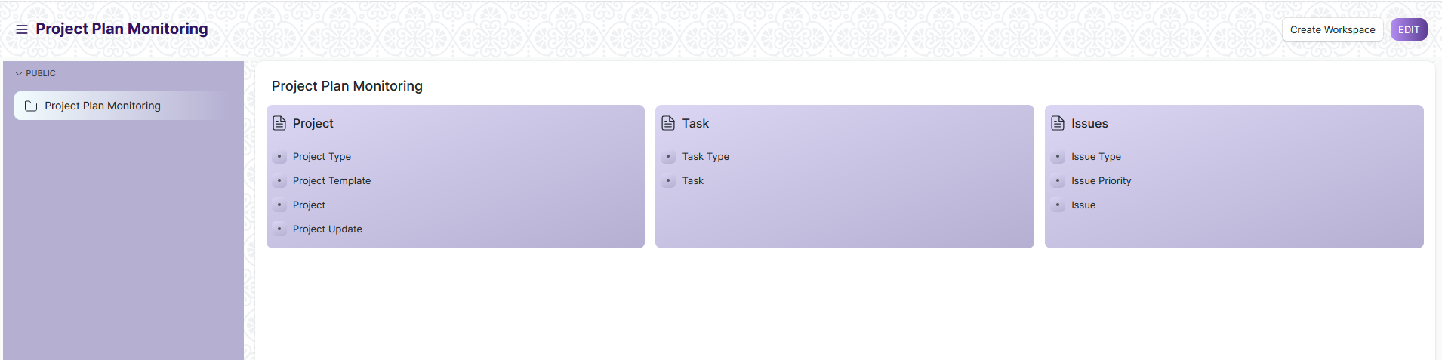

* Go to the required screen.
* Click on the ***“+Add Screen Name”*** button in the right corner of the screen.

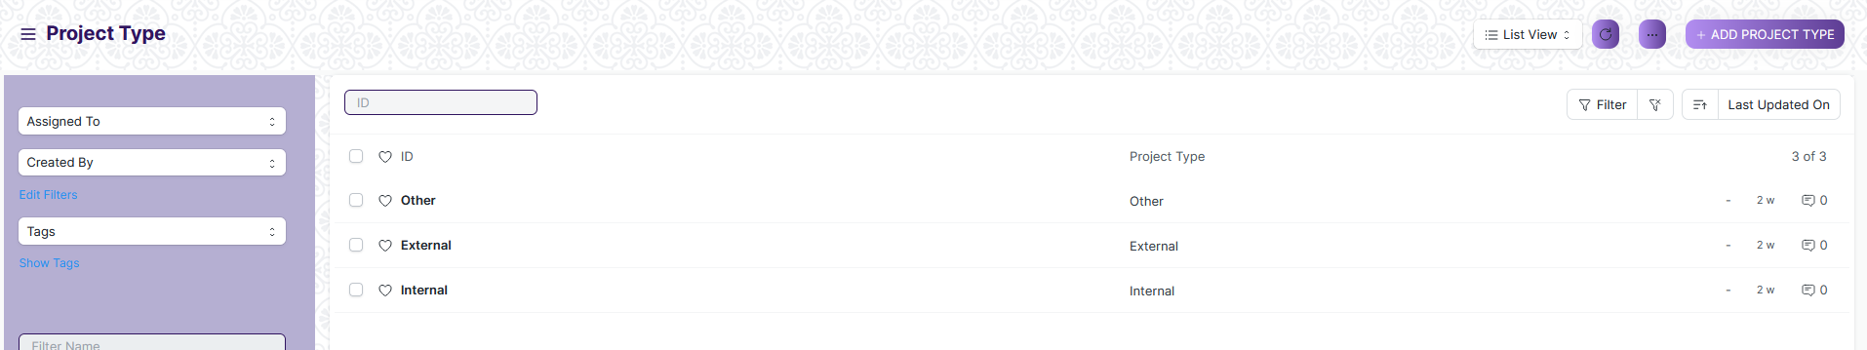

(Example : For addition in the new Project Type form , click +Add Project Type button).

* Enter the required data.
* Click on “***Save”*.**
* After saving , the record will be visible in the List View of the screen.



(Example : List view of saved Project Type)

**Note** : The process of creation can only be carried out by User who have necessary permission.Kindly refer to the Screen wise permission section in the document.

**View a Saved Document**

* Log in to the system.
* Go to the required workspace
* Go to the required screen.
* Click on the required document from the list view of the screen.



(Example : View of “as” Document of Project Type Screen)

View the clicked document.

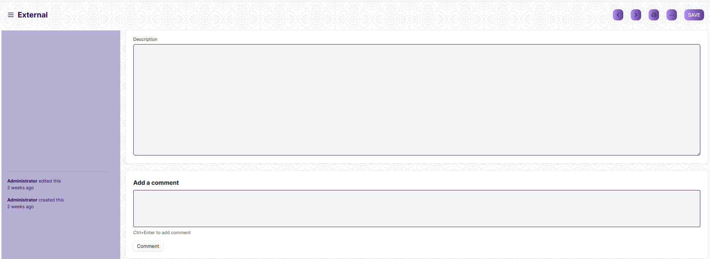

(Example : View of the “as” External)

**Note :** The process of view can only be carried out by employees who have necessary permission.Kindly refer to the Screen wise permission section in the document.

**Delete a Saved Document**

* Log in to the system
* Go to the required workspace
* Go to the required screen.
* Click on the required document from the list view of the screen.
* Click on the 3 dots in the right corner of the screen.
* Click on *“****Delete”*.**

**Note :** If the document you are deleting is linked with any other document then first unlink it , then try to delete.

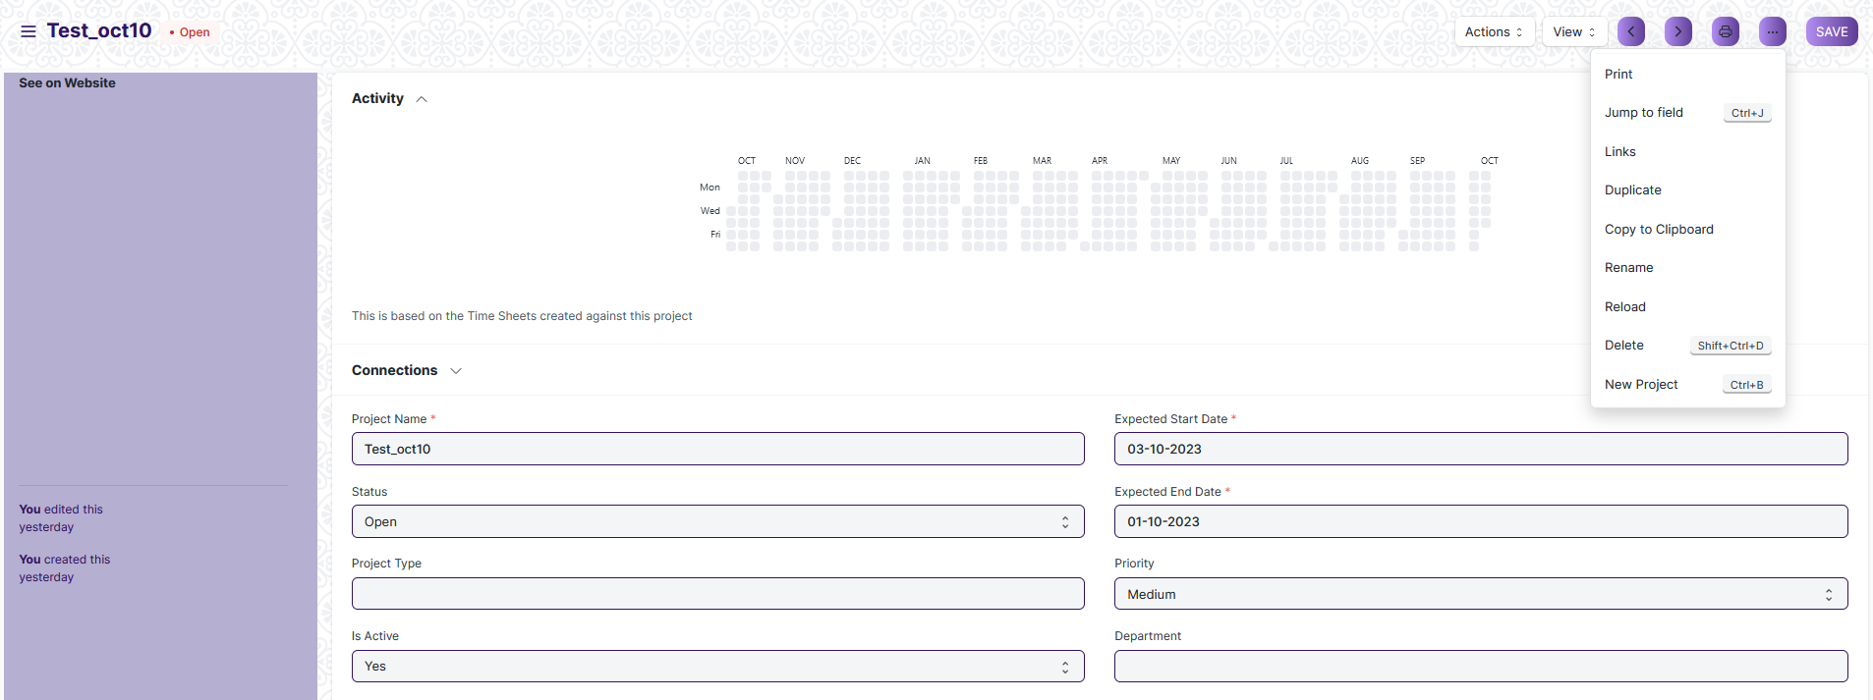

(Example : Deletion of “Test_oct10” document of Project)

* Click yes if you want to delete the selected document.

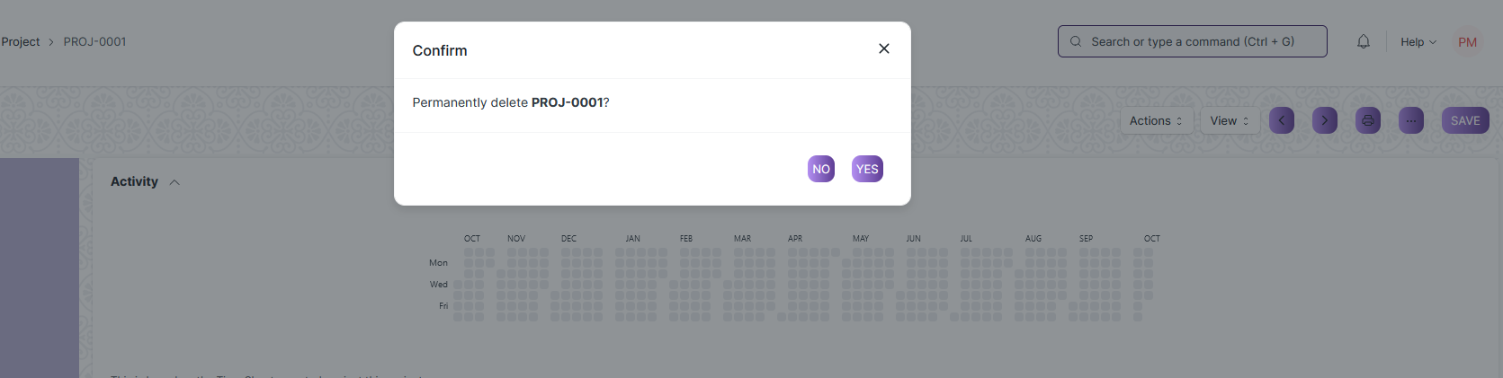

(Example : Clicking Yes to Delete permanently the document)

**Note :** The process of deletion can only be carried out by employees who have necessary permission.Kindly refer to the Screen wise permission section in the document.

**Rename a Saved Document**

* Login to the screen.
* Go to the required workspace
* Go to the required screen.
* Click on the required document from the list view of the screen.
* Click on the 3 dots in the right corner of the screen.
* Click on *“****RENAME”*** .



* Click on *“****Rename”*** button to rename the document.

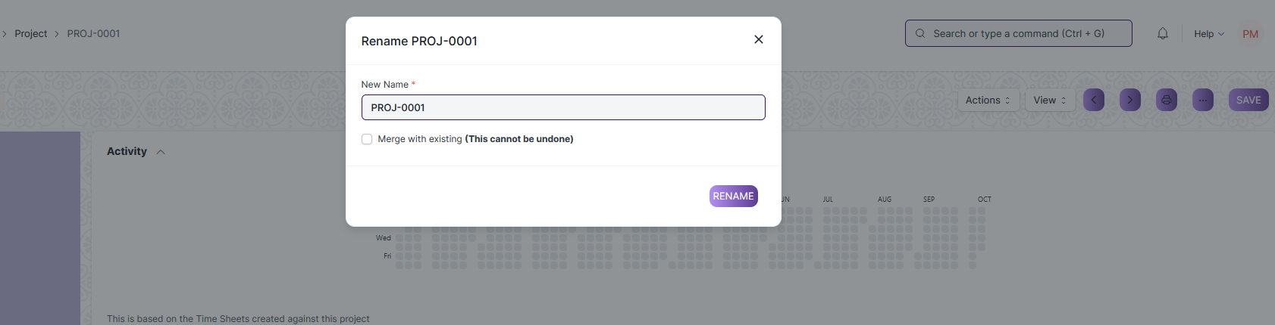

**Note :** The process of deletion can only be carried out by employees who have necessary permission.Kindly refer to the Screen wise permission section in the document.

**Print a Saved Document type**

* Login to the system
* Go to the required workspace
* Go to the required screen.
* Click on a saved document on the screen.
* Click on the print button presented in the right corner of the screen.

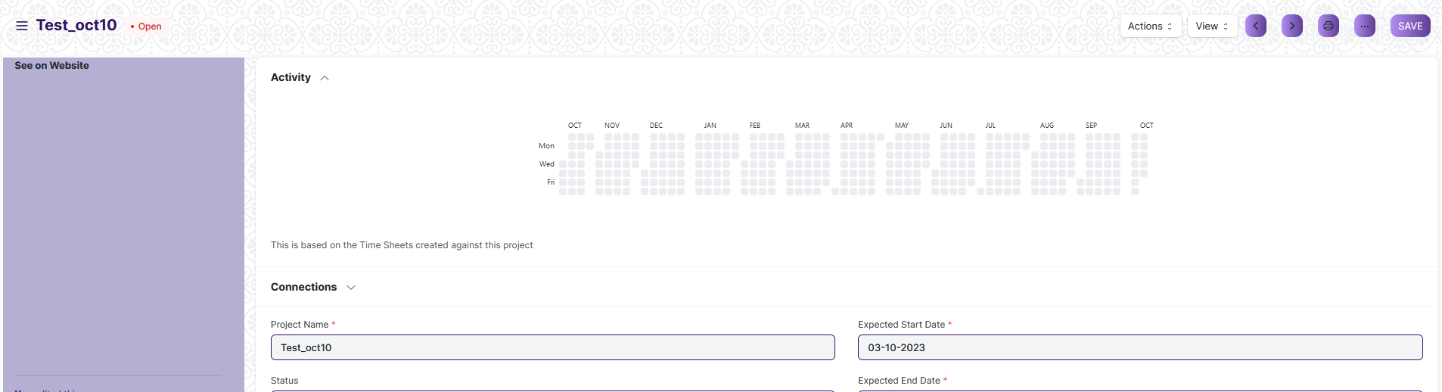

* A new screen will open.
* Click on the print button to print the document.

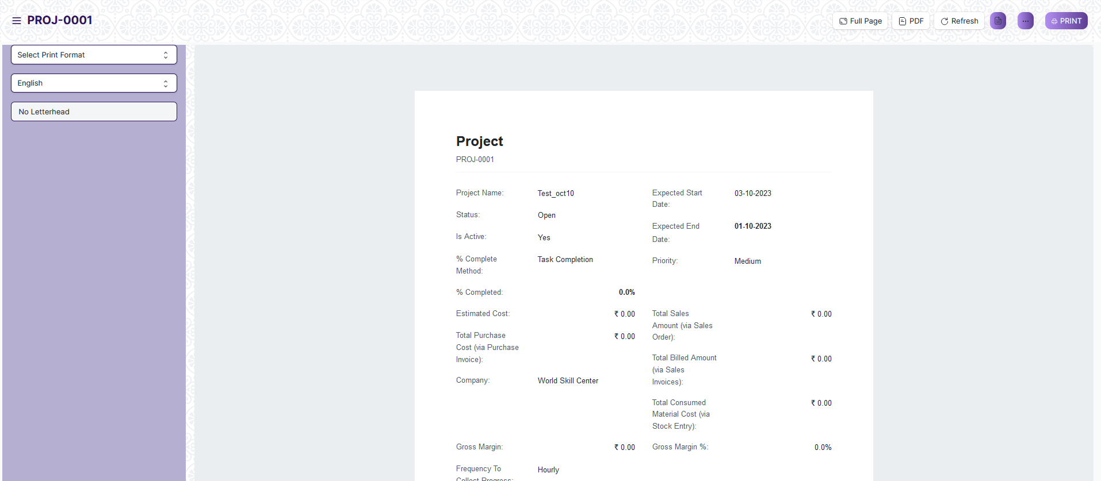

* To download the employment type as PDF , click on the PDF button .



**Note :** The process of printing can only be carried out by employees who have the necessary permission.

**View the saved document in different format.**

* Login to the system
* Go to the required workspace
* Go to the required screen.
* Click on the List View Button in the screen.

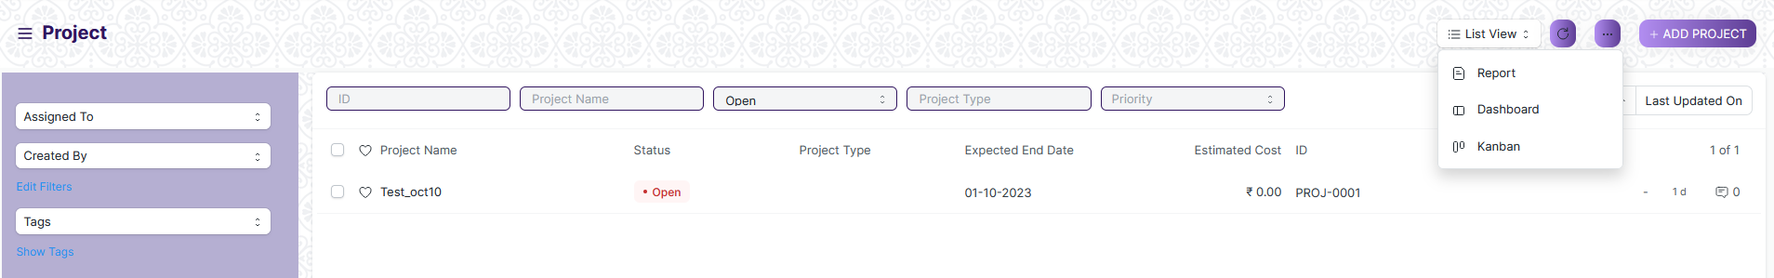

* Select the appropriate view type that you want.

**Note :** The List view button can only be showed to the employees who have necessary permission.

**View the saved documents by applying filters.**

* Login to the screen.
* Go to the required workspace.
* Go to the required screen.
* Click on the ***“Filter”***.

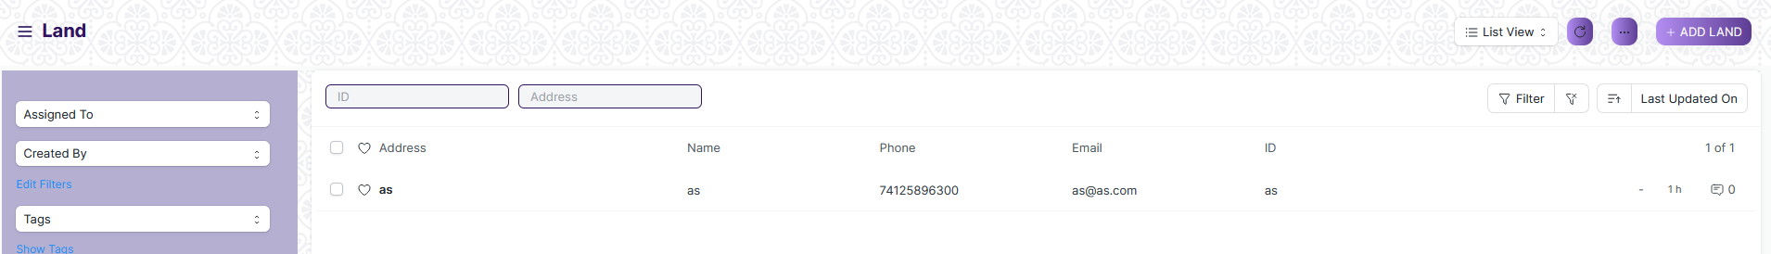

* Select the field of the document based on which you wish to filter the records. All the fields in a form will be selectable in this list.

Value

Based on

Criteria

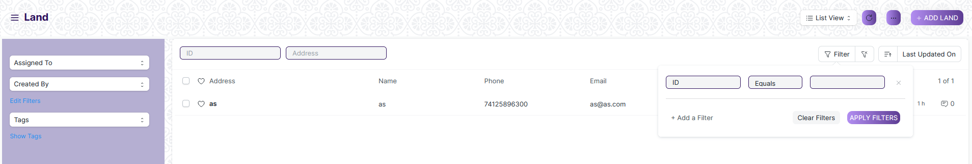

**Based On :** For the field, you will be required to put a value of the field. In the 'based on' field.

**Criteria :** You can define criteria based on which the system will search the document.The different conditions on which the filters are based are: Equals, Not Equal, Like, Not Like, In, Not In, =,>,< etc.

**Value :** Here, you will be required to enter the value for which you are running the document search.

**Some Examples of Viewing the documents in the list view after applying filters.**

Filter on Building Type room screen where Is Group Equals to Yes. After clicking the Apply Filter button, all the filtered document will show in the screen.

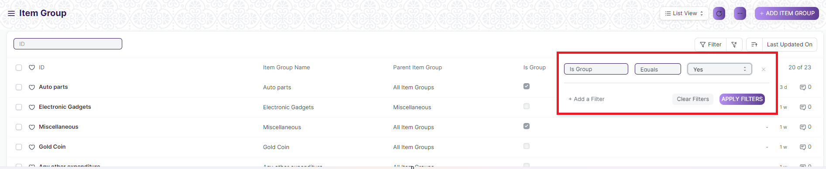

Filter on Task Type Screen where, the Item Group Name starts with ‘A’.

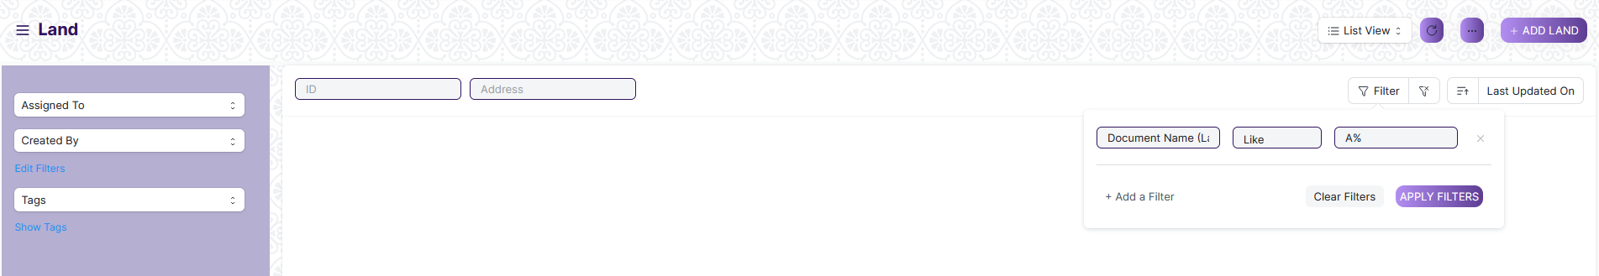

You can also apply multiple filters at a time. To remove a specific filter, just click on 'x' sign on it. To add another filter Click on the +Add a Filter button.

**Example of Multiple filter .**

Applying filter in the Task Type screen , where the Document Name starts with ‘A’. and ID equals as.

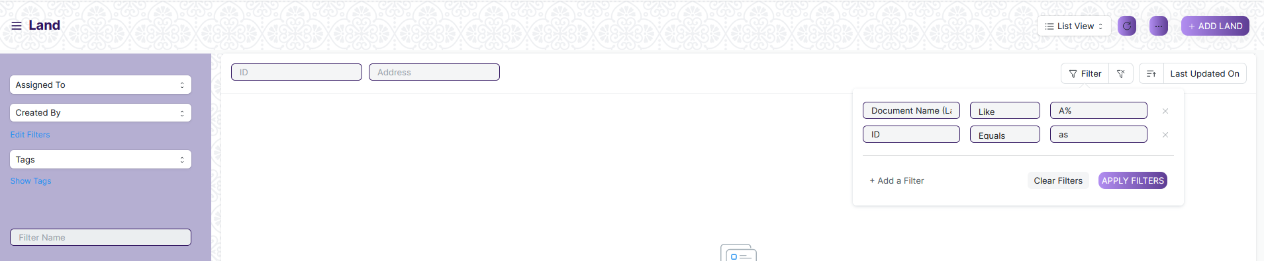

**Default Filters**

There are some filters present out of the box for the views which can be used for filtering the search results.

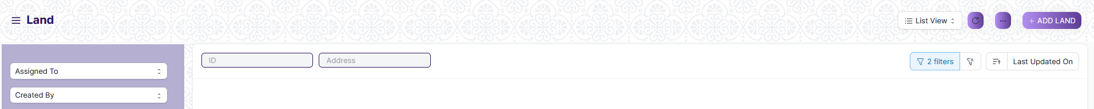

**Note :** The Filter Option can only be showed to the User who have necessary permission.

## General Procedure for Submitted Document

**Create of New document**

* Login in to the system
* Go the required workspace
* Go to the required screen.
* Click on the ***“+Add Screen Name”*** button in the right corner of the screen.

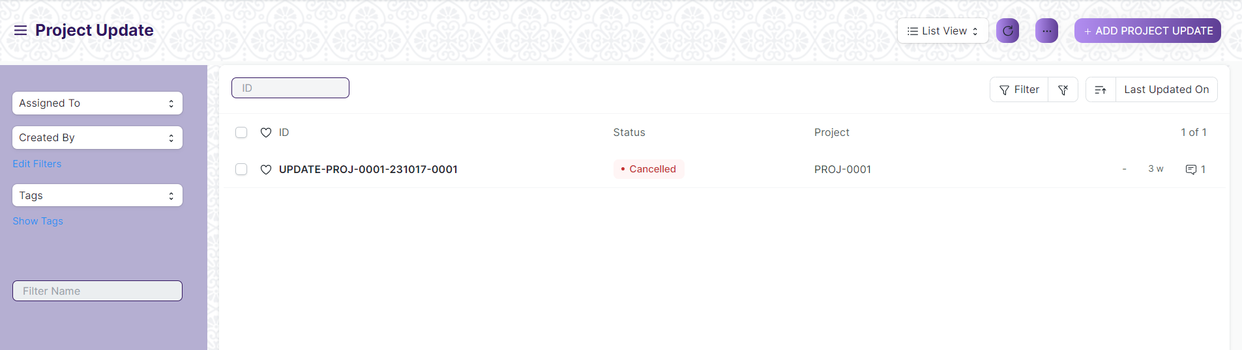

(Example : For addition in the new Project Update, click +Add Project Update button).

* Enter the required information in the document.
* Once you are finished entering the information , click the ***“Save”*** button.
* After saving it , a submit button will appear.

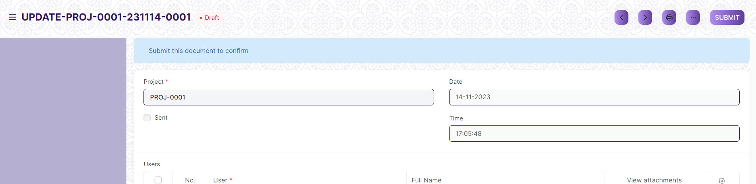

* Click on the **“Submit”** button.
* A confirmation dialog box will appear . Click the Yes button to submit the document.

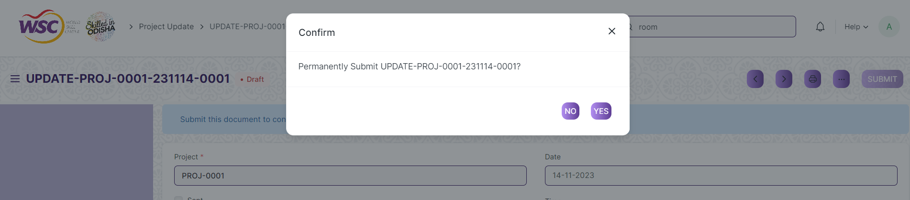

* After submitting , the record will be visible in the List View of the screen.

**Note :** The process of creation can only be carried out by employees who have necessary permission.Kindly refer to the Screen wise permission section in the document.

**Cancel a Submitted Document**

* Log in to the system.
* Go to the required workspace
* Go to the required screen.
* Click on the required document from the list view of the screen.
* Click the ***“Cancel”*** Button .

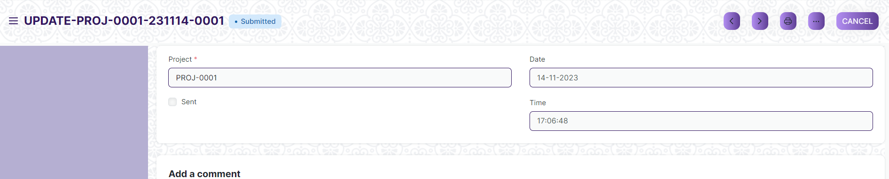

* A confirmation dialog box will appear . Click the Yes button to cancel the document.

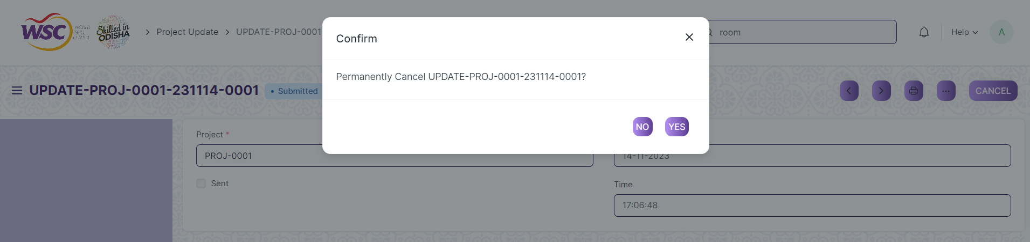

**Note :** The process of cancellation can only be carried out by employees who have necessary permission.Kindly refer to the Screen wise permission section in the document.

**Amend a Submittable Document**

* Log in to the system.
* Go to the required workspace
* Go to the required screen.
* Click on the required document from the list view of the screen.
* After cancellation of the document , an Amend button will appear on the screen.

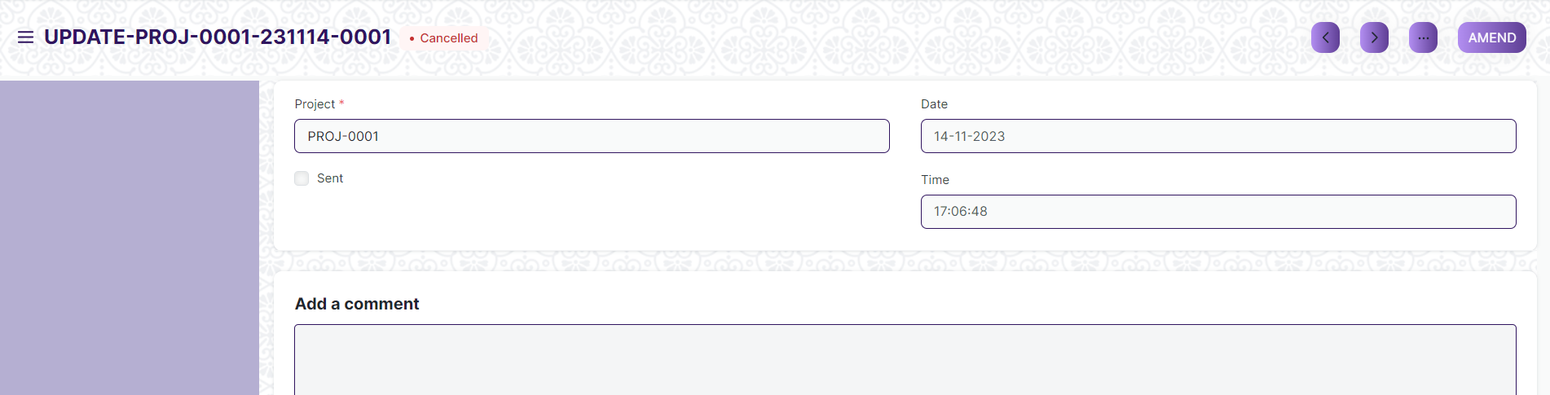

* Click the “***Amend”*** button.
* A new document will be created with the same information as the original document .

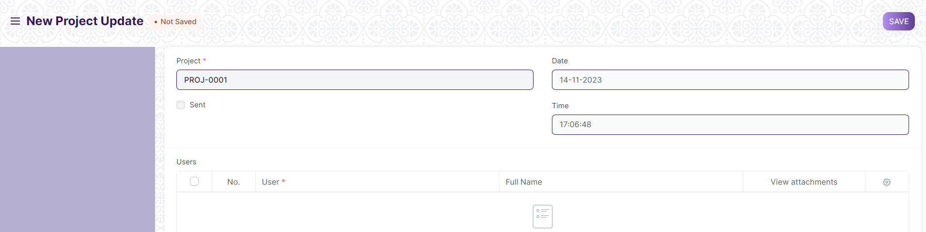

* You can now make changes to the document as needed.

**Note :** The process of Amend can only be carried out by employees who have necessary permission.Kindly refer to the Screen wise permission section in the document.

**Action Menu on a document.**

The three dots menu, located in the right corner of a document in a Screen , offers a range of actions and options to manage and interact with the document.

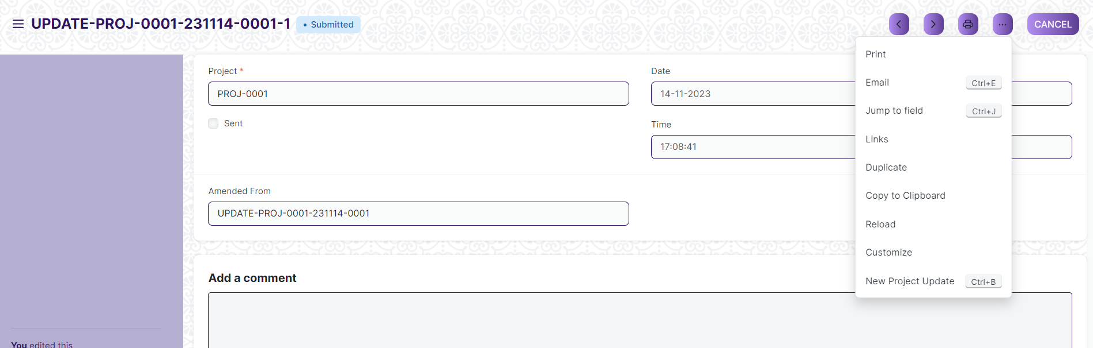

The functionalities available in the three dots menu are given below .

**Print :** Print Enables you to generate a printable version of the document ., which you can save as a PDF or send to a printer.

**Email :** Click on Email allows you to send the document as an attachment via email to specified recipients.

**Duplicate :** Create a new document with the same information as the current one.

**Delete :** Permanently remove the document.

**Cancel :** Cancel the submitted document.

**Submit :** Submit the document . If the document is submittable.

**Links :** This Option displays a list of document that are linked to the current document. You can navigate these linked documents from here.

**Jump to field :** You can directly go the required field by clicking this option and giving appropriate field name.

**Copy to Clipboard :** By clicking this option you can copy the content of the document .

**Rename :** By clicking the Rename option you can Rename the document.

**Note :** These options will be visible to User who have necessary permission.

# Project

## Project Type

A Project Type is the classification of projects into different types to group similar kind of projects.

The screen is accessible to Project Manager, Employee

To access the Project Type List ,go to :

***Home > Project Plan Monitoring > Project > Project Type***

Screen Type : Save

**Adding a new Project Type**

As it is a save screen, follow the general procedure to create a save document as mentioned above .

* Go to the Project Type List and click on New
* Add the name of the Project Type and description
* Save

After creating an Project Type, the record will be visible in the List view of the screen.

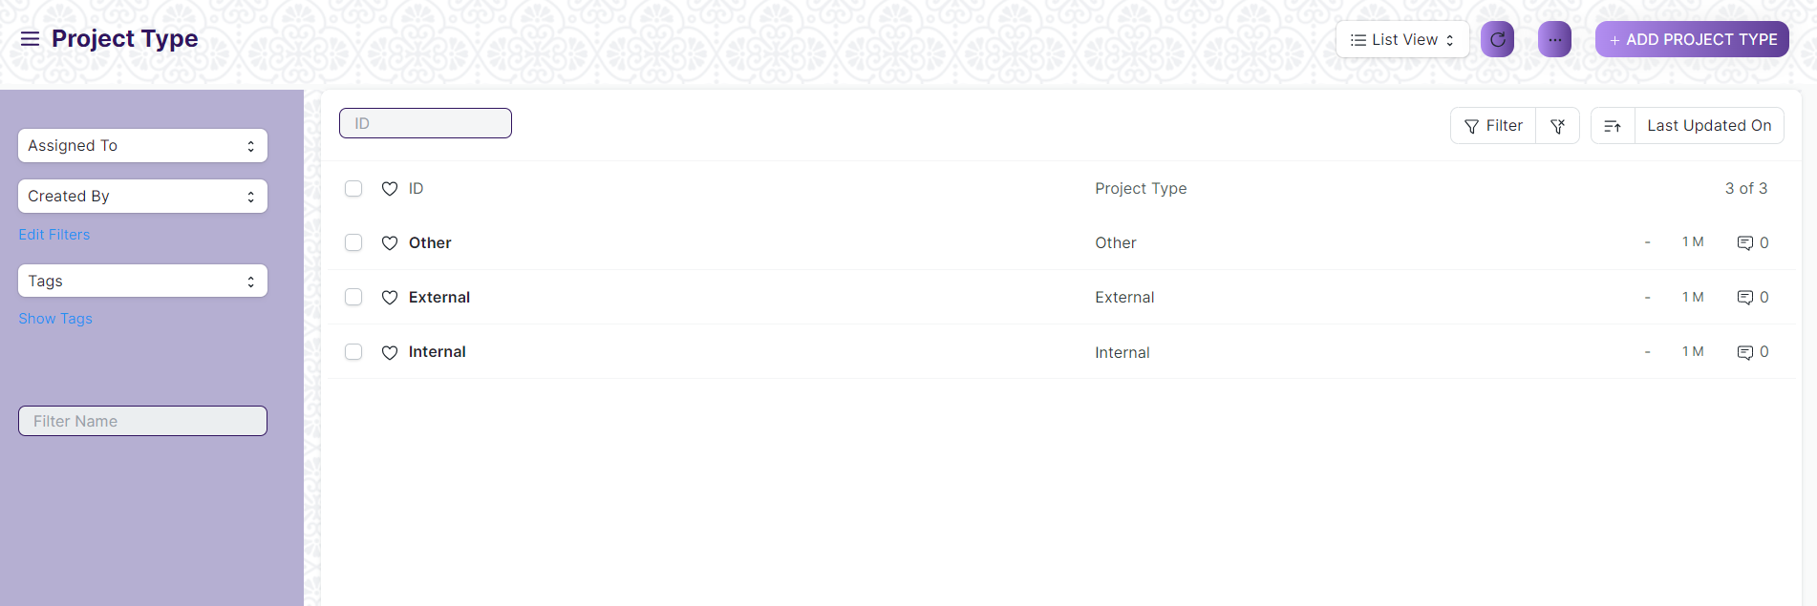

(List View of Project Type)

**View Project Type**

As it is a Save screen, follow the general procedure to view a save document as mentioned above .

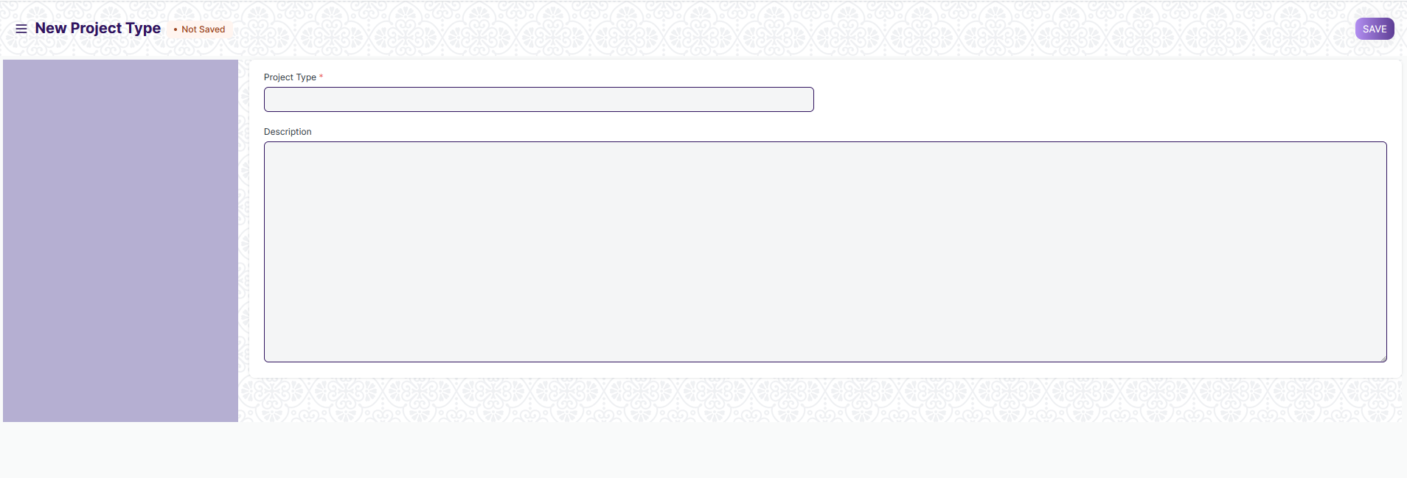

(View of a save Project Type)

**Delete Project Type**

As it a save screen , follow the general procedure to delete a save document .

**Edit Project Type**

Edit the field that you want to change.

Click on Save.

**Print Project Type**

As it is a save screen , follow the general procedure to print a save document.

## Project Template

A Project Template is a predefined sequence of tasks arranged in stipulated schedule.

The screen is accessible to Project Manager, Employee

To access the Land List ,go to :

***Home > Project Plan Monitoring > Project > Project Template***

Screen Type : Save

**Adding a new Project Template**

As it is a save screen, follow the general procedure to create a save document as mentioned above .

* Go to the Project Template List and click on New
* Add the following details:
* Project Template Name: Title of the Project Template
* Project Type: Project Templates, just like projects can be classified into different project types, e.g., Internal or External
* Tasks: Each Project Template will have a set of a predefined sequence of tasks. In this table, you can select the tasks you want for this template

After creating an Project Template, the record will be visible in the List view of the screen.

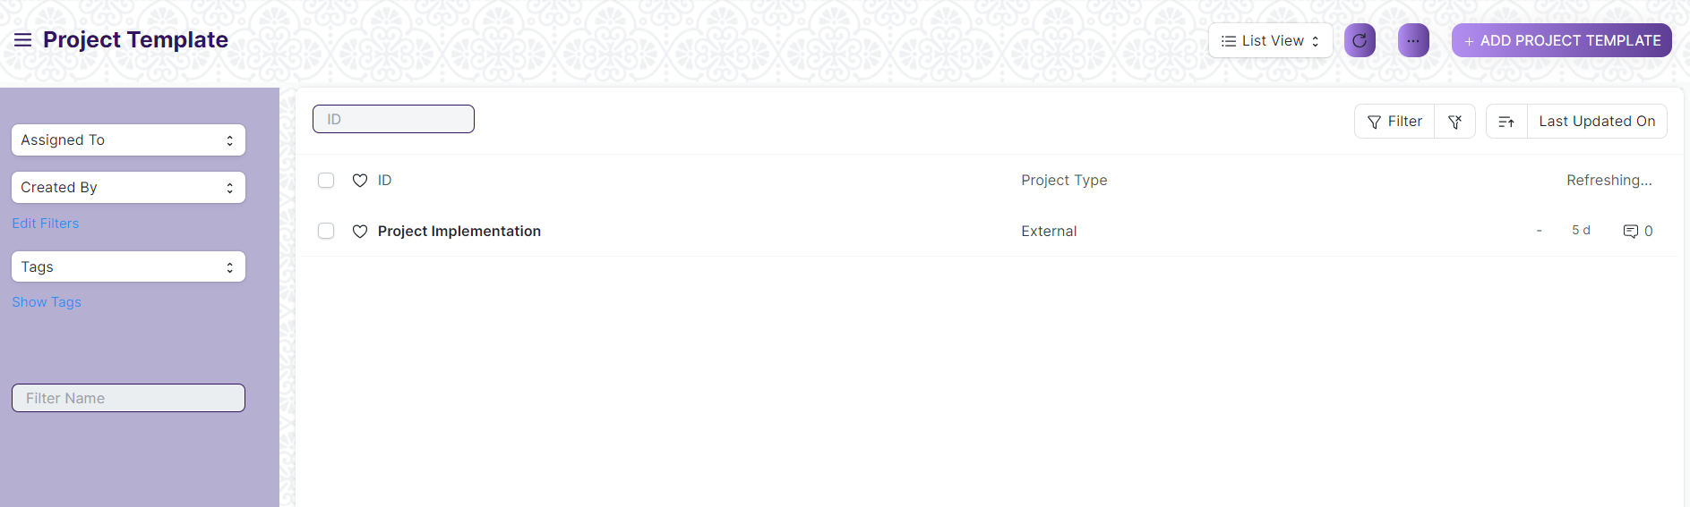

(List View of Project Template)

**View Project Template**

As it is a Save screen, follow the general procedure to view a save document as mentioned above .

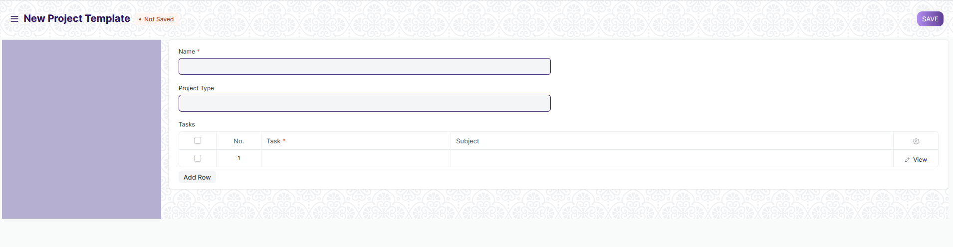

(View of a save Project Template)

**Delete Project Template**

As it a save screen , follow the general procedure to delete a save document .

**Edit Project Template**

Edit the field that you want to change.

Click on Save.

**Print Project Template**

As it is a save screen , follow the general procedure to print a save document.

## Project

A Project is a planned piece of work that is designed to find information about something, to produce something new, or to improve something.

The screen is accessible to Project Manager, Employee

To access the Project List ,go to :

***Home > Project Plan Monitoring > Project > Project***

Screen Type : Save

**Adding a new Project**

As it is a Save screen, follow the general procedure to create a Save document as mentioned above .

* Go to the Project list and click on New.
* Add the following details:
* Project Name: Title of the Project.
* Status: The default status of a Project is going to be 'Open' which can later be changed to 'Completed' or 'Cancelled'.
* Expected End Date: Enter the date on which you aim to finish the project.
* Save.

After creating an Project , the record will be visible in the List view of the screen.

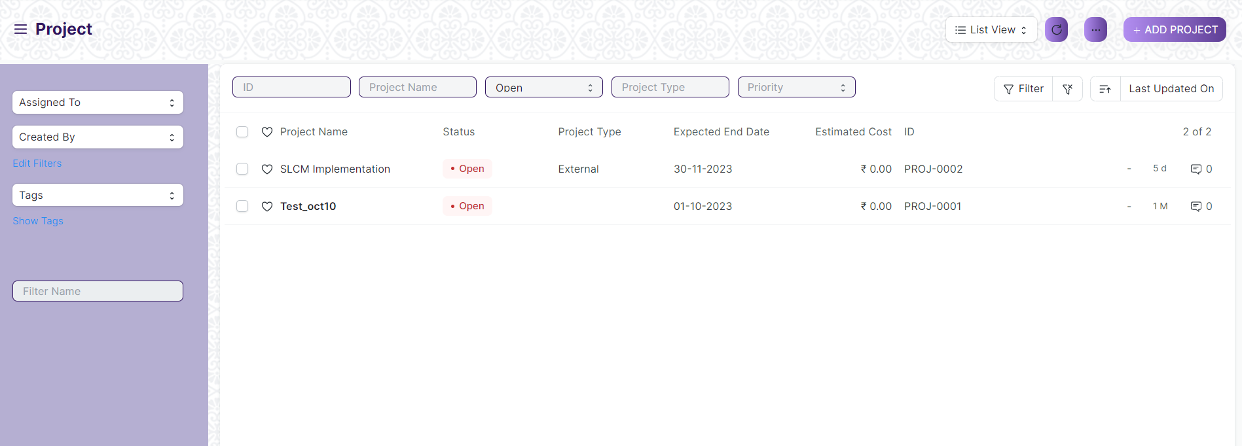

(List View of Project )

**View Project**

As it is a Save screen, follow the general procedure to view a Save document as mentioned above .

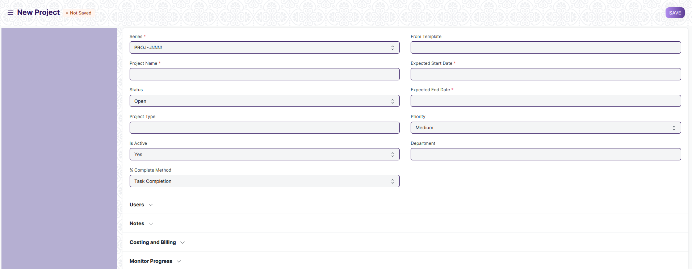

(View of a Save Project)

**Delete Project**

As it a Save screen , follow the general procedure to delete a Save document .

**Edit Project**

Edit the field that you want to change.

Click on Save.

**Print Project**

As it is a Save screen , follow the general procedure to print a Save document.

## Project Update

A Project Update is the status of the Project which can be sent to all the stakeholders of the Project.

The screen is accessible to Project Manager, Employee

To access the Project Update List ,go to :

***Home > Project Plan Monitoring > Project > Project Update***

Screen Type : Submit

**Adding a new Project Update**

As it is a save screen, follow the general procedure to create a save document as mentioned above .

* Go to the Project Update List and click on New.
* Add the name of the Project for which you want to send an update.
* Add the name of the Users to whom you want to send the Project Update in the Child Table. These Users could be your Customers or any other Internal or External Stake Holders.
* Save and Submit.

After creating an Project Update, the record will be visible in the List view of the screen.

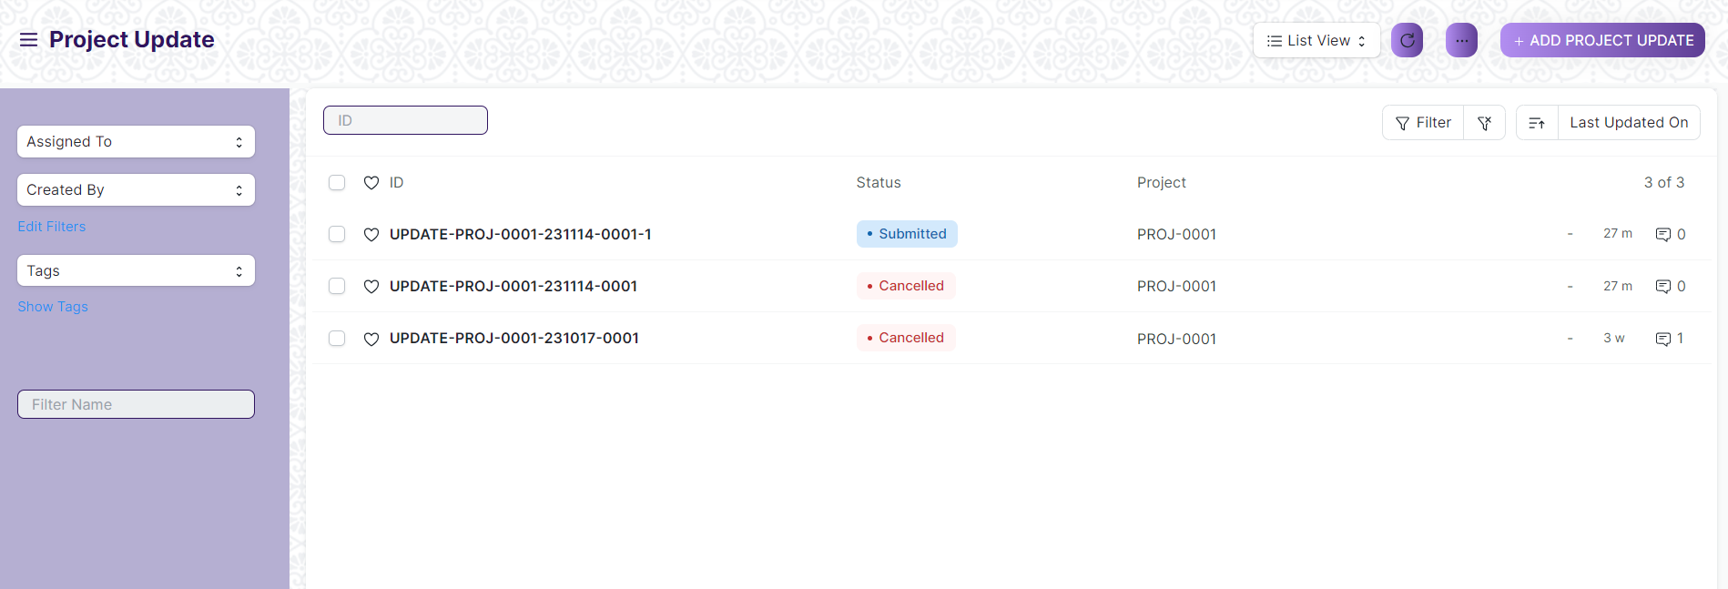

(List View of Project Update)

**View Project Update**

As it is a Submit screen, follow the general procedure to view a Submit document as mentioned above .

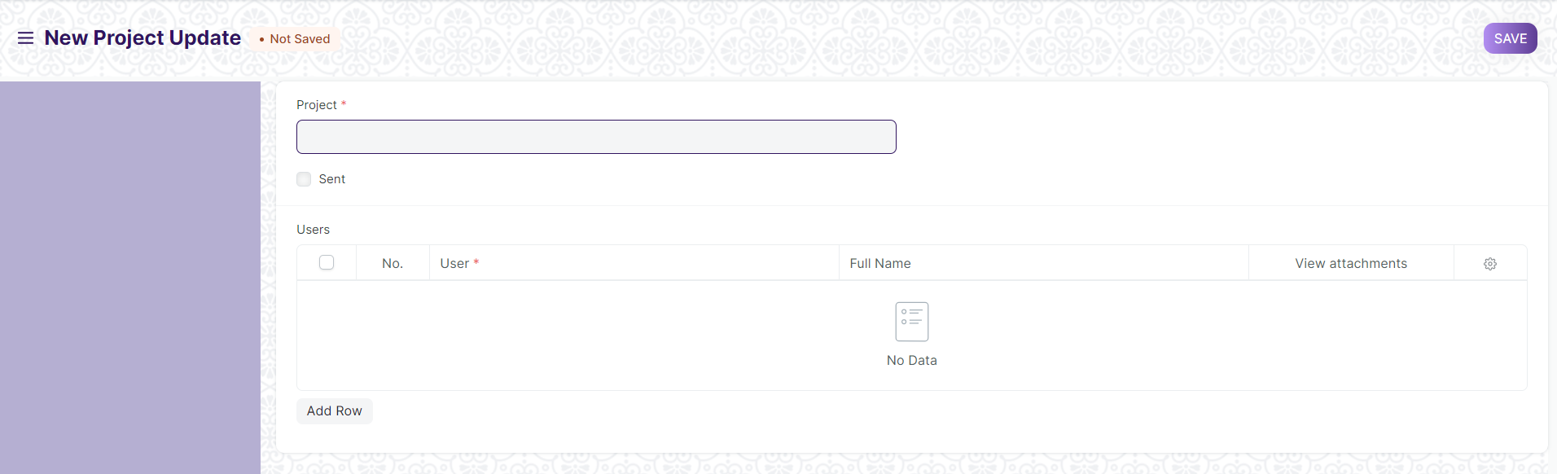

(View of a Submit Project Update room)

**Delete Project Update**

As it a Submit screen , follow the general procedure to delete a Submit document .

**Edit Project Update**

Edit the field that you want to change.

Click on Save and Submit.

**Print Project Update**

As it is a Submit screen , follow the general procedure to print a Submit document.

# Task

## Task Type

"Task Type" refers to a categorization or classification of tasks within the system. Tasks are activities or work items that need to be completed, and organizing them by task type can help in managing and tracking various types of work within an organization.

The screen is accessible to Project Manager, Employee

To access the Task Type List ,go to :

***Home > Project Plan Monitoring > Task > Task Type***

Screen Type : Save

**Adding a new Task Type**

As it is a Save screen, follow the general procedure to create a Save document as mentioned above .

* Go to the Task type list and click on New.
* Enter Name, Weight and description.
* Click on Save.

After creating an Task type, the record will be visible in the List view of the screen.

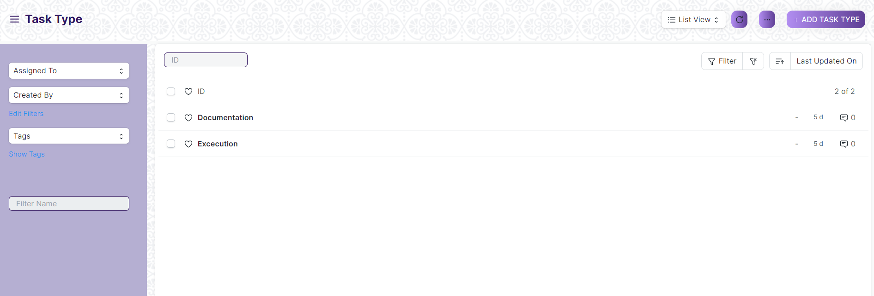

(List View of Task Type)

**View Task Type**

As it is a Save screen, follow the general procedure to view a Save document as mentioned above .

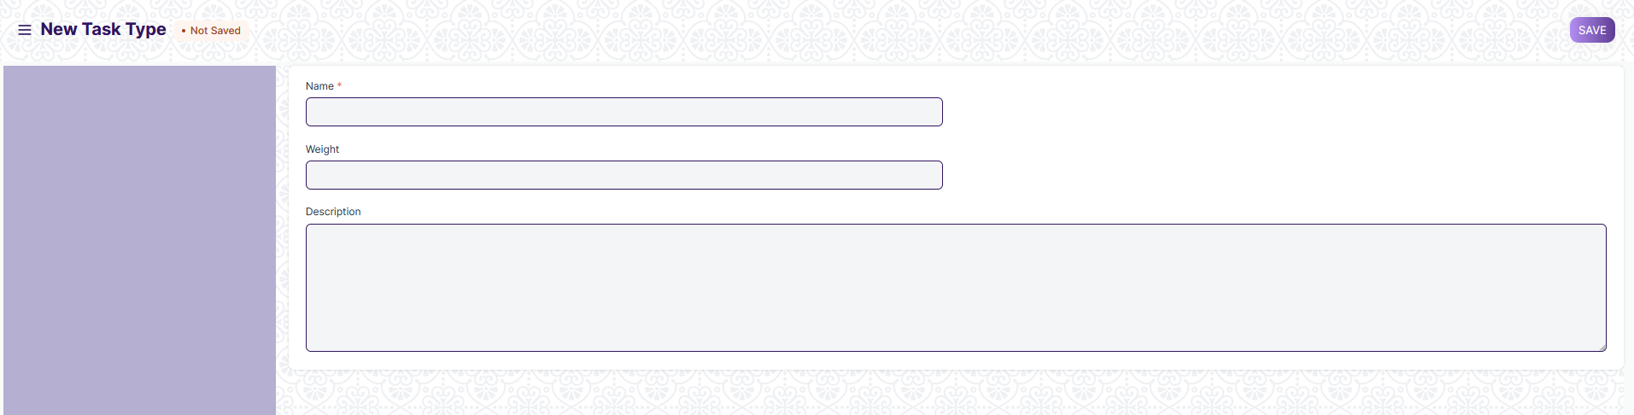

(View of a Save Task Type)

**Delete Task Type**

As it a Save screen , follow the general procedure to delete a Save document .

**Edit Task Type**

Edit the field that you want to change.

Click on Save.

**Print Task Type**

As it is a Save screen , follow the general procedure to print a Save document.

## Task

A task is an actionable unit or activity which needs to be completed.

The screen is accessible to Project Manager, Employee

To access Task, go to:

***Home > Project Plan Monitoring > Task > Task***

Screen Type : Save

**Adding a new Task**

As it is a Submit screen, follow the general procedure to create a Submit document as mentioned above .

* Go to the Task List and click on New.
* Add the subject of the task.
* Save.

After creating an Task, the record will be visible in the List view of the screen.

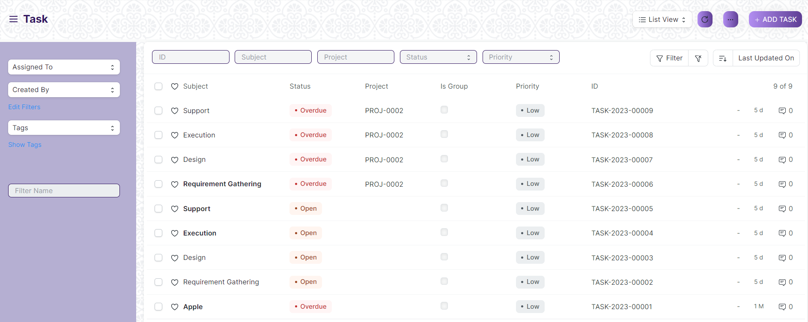

(List View of Task)

**View Task**

As it is a Save screen, follow the general procedure to view a Save document as mentioned above .

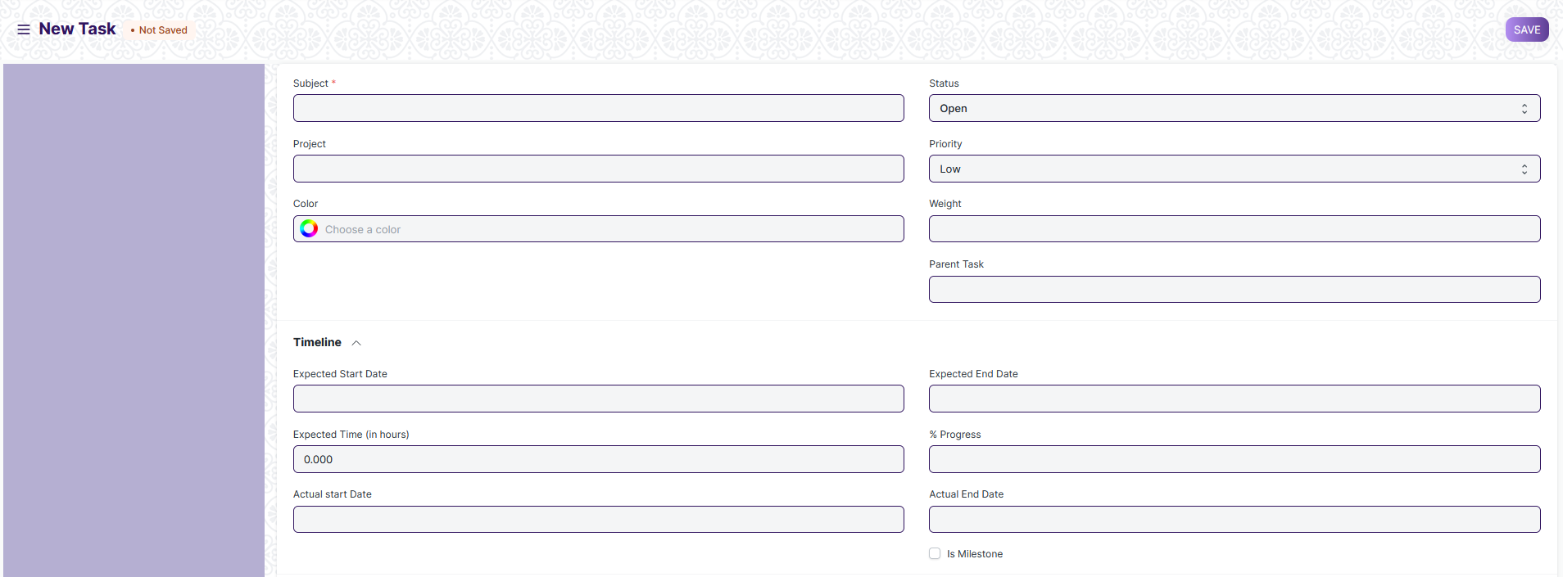

(View of a Save Asset)

**Delete Task**

As it a Save screen , follow the general procedure to delete a Save document .

**Edit Task**

Edit the field that you want to change.

Click on Save.

**Print Task**

As it is a Save screen , follow the general procedure to print a Save document.

# Issues

## Issue Type

Issue Type is useful for tagging and classifying Issues.

The screen is accessible to Project Manager, Employee

To access the Issue Type List ,go to :

***Home > Project Plan Monitoring >Issues > Issue Type***

Screen Type : Save

**Adding a new Issue Type**

As it is a Save screen, follow the general procedure to create a Save document as mentioned above .

* Go to the Issue Type, click on New.
* Enter a name for the type.
* Enter description.
* Save.

After creating an Issue Type, the record will be visible in the List view of the screen.

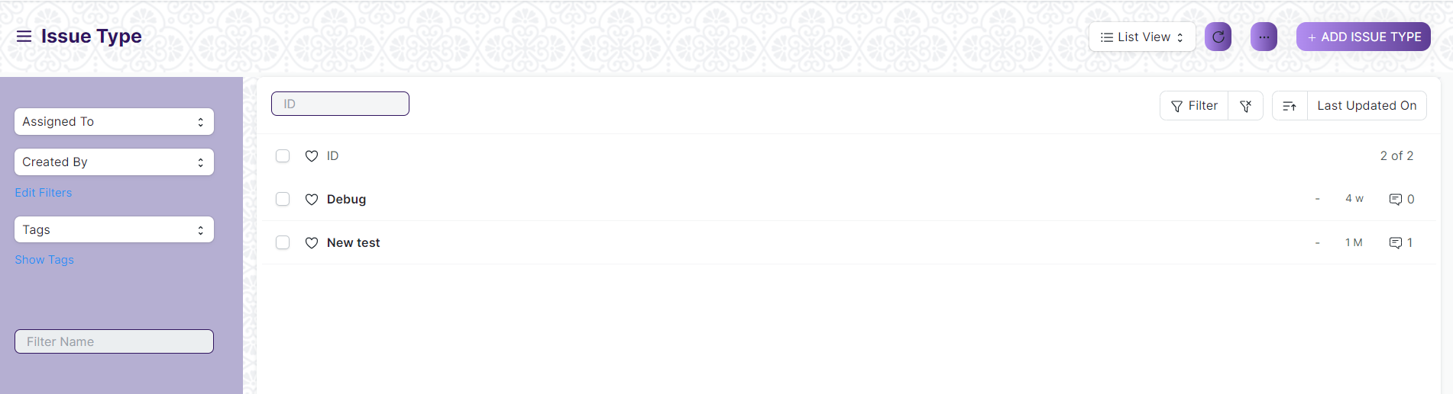

(List View of Issue Type)

**View Issue Type**

As it is a Save screen, follow the general procedure to view a Save document as mentioned above .

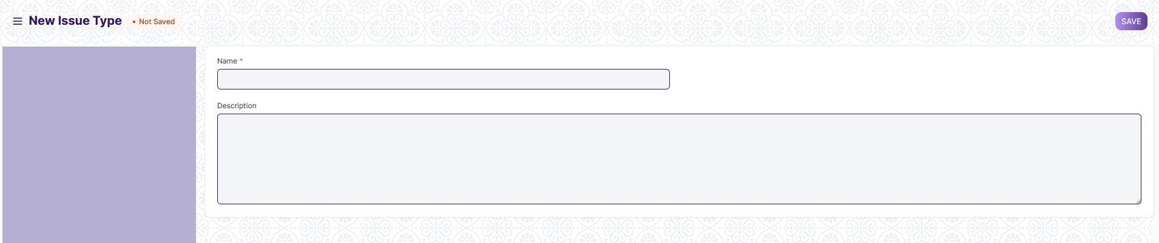

(View of a Save Issue Type)

**Delete Issue Type**

As it a Save screen , follow the general procedure to delete a Save document .

**Edit Issue Type**

Edit the field that you want to change.

Click on Save.

**Print Issue Type**

As it is a Save screen , follow the general procedure to print a Save document.

## Issue Priority

Issue Priority indicates the urgency of solving an Issue

The screen is accessible to Project Manager, Employee

To access the Issue Priority ,go to :

***Home > Project Plan Monitoring >Issues > Issue Priority***

Screen Type : Save

**Adding a new Issue Priority**

As it is a Save screen, follow the general procedure to create a Save document as mentioned above .

* Go to the Issue Priority list, click on New.
* Enter a name and description for the type
* Click on Save.

After creating an Issue Priority , the record will be visible in the List view of the screen.

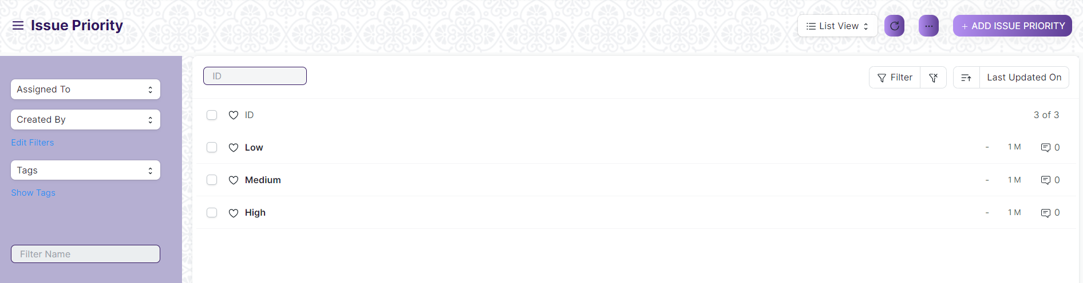

(List View of Issue Priority)

**View Issue Priority**

As it is a Save screen, follow the general procedure to view a Save document as mentioned above .

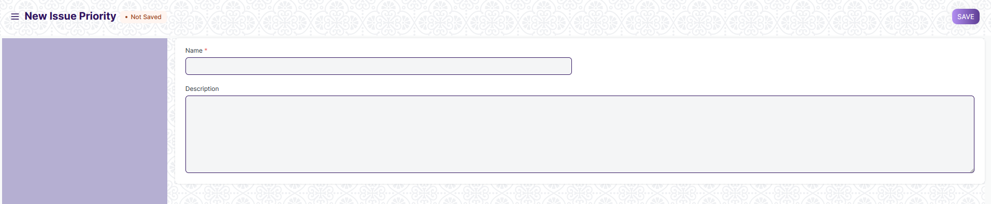

(View of a Save Issue Priority)

**Delete Issue Priority**

As it a Save screen , follow the general procedure to delete a Save document .

**Edit Issue Priority**

Edit the field that you want to change.

Click on Save.

**Print Issue Priority**

As it is a Save screen , follow the general procedure to print a Save document.

## Issue

An Issue is an incoming query.

The screen is accessible to Project Manager, Employee

To access the Asset Maintenance Log, go to :

***Home > Project Plan Monitoring >Issues > Issue***

Screen Type : Save

**Adding a new Issue**

As it is a Save screen, follow the general procedure to create a Save document as mentioned above .

* Go to the Issue list, click on New.
* Enter the Subject, Raised By, and a description of the Issue.
* Save.

After creating an Issue , the record will be visible in the List view of the screen.

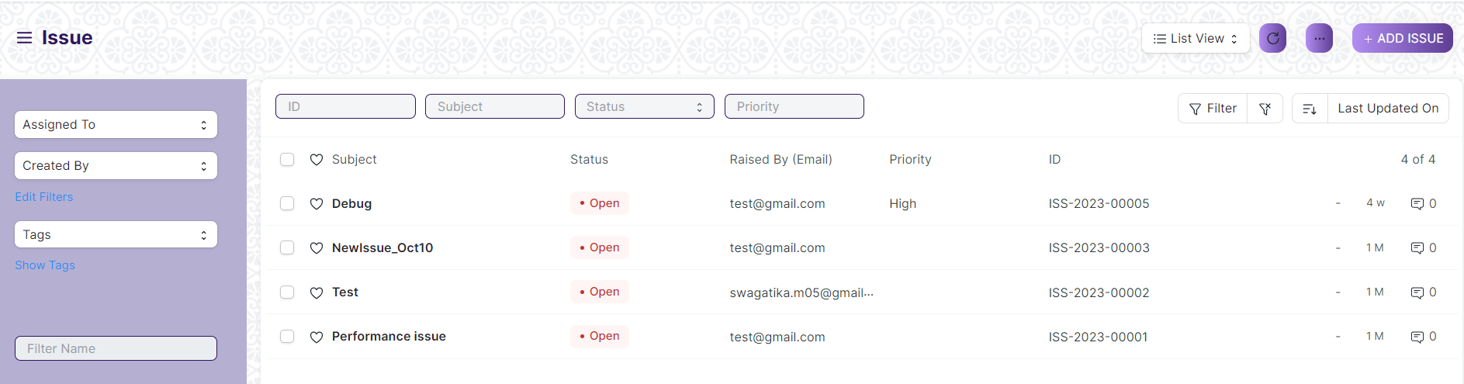

(List View of Issue)

**View Issue**

As it is a Save screen, follow the general procedure to view a Save document as mentioned above .

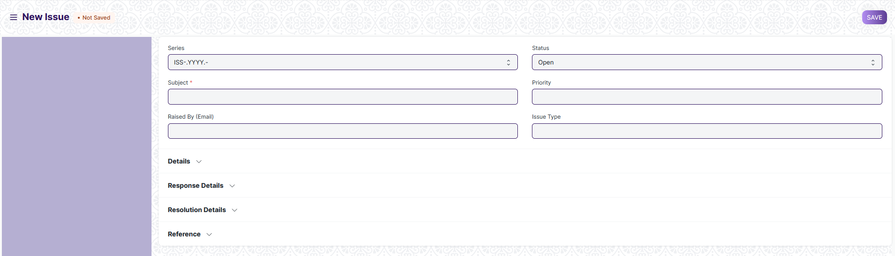

(View of a Save Issue)

**Delete Issue**

As it a Save screen , follow the general procedure to delete a Save document .

**Edit Issue**

Edit the field that you want to change.

Click on Submit.

**Print Issue**

As it is a Save screen , follow the general procedure to print a Save document.

# Roles and Permissions

## Project Type

|  |  |  |  |  |  |  |  |  |  |
| --- | --- | --- | --- | --- | --- | --- | --- | --- | --- |
| **ID** | **Role** | **Select** | **Read** | **Write** | **Create** | **Delete** | **Submit** | **Cancel** | **Amend** |
| 1 | Project Manager | Yes | Yes | Yes | Yes | Yes | NA | NA | NA |
| 2 | Employee | No | Yes | No | No | No | NA | NA | NA |

## Project Template

|  |  |  |  |  |  |  |  |  |  |
| --- | --- | --- | --- | --- | --- | --- | --- | --- | --- |
| **ID** | **Role** | **Select** | **Read** | **Write** | **Create** | **Delete** | **Submit** | **Cancel** | **Amend** |
| 1 | Project Manager | Yes | Yes | Yes | Yes | Yes | NA | NA | NA |
| 2 | Employee | No | Yes | No | No | No | NA | NA | NA |

## Project

|  |  |  |  |  |  |  |  |  |  |
| --- | --- | --- | --- | --- | --- | --- | --- | --- | --- |
| **ID** | **Role** | **Select** | **Read** | **Write** | **Create** | **Delete** | **Submit** | **Cancel** | **Amend** |
| 1 | Project Manager | Yes | Yes | Yes | Yes | Yes | NA | NA | NA |
| 2 | Employee | No | Yes | No | No | No | NA | NA | NA |

## Project Update

|  |  |  |  |  |  |  |  |  |  |
| --- | --- | --- | --- | --- | --- | --- | --- | --- | --- |
| **ID** | **Role** | **Select** | **Read** | **Write** | **Create** | **Delete** | **Submit** | **Cancel** | **Amend** |
| 1 | Project Manager | Yes | Yes | Yes | Yes | Yes | NA | NA | NA |
| 2 | Employee | No | Yes | No | No | No | NA | NA | NA |

## Task Type

|  |  |  |  |  |  |  |  |  |  |
| --- | --- | --- | --- | --- | --- | --- | --- | --- | --- |
| **ID** | **Role** | **Select** | **Read** | **Write** | **Create** | **Delete** | **Submit** | **Cancel** | **Amend** |
| 1 | Project Manager | Yes | Yes | Yes | Yes | Yes | NA | NA | NA |
| 2 | Employee | No | Yes | No | No | No | NA | NA | NA |

## Task

|  |  |  |  |  |  |  |  |  |  |
| --- | --- | --- | --- | --- | --- | --- | --- | --- | --- |
| **ID** | **Role** | **Select** | **Read** | **Write** | **Create** | **Delete** | **Submit** | **Cancel** | **Amend** |
| 1 | Project Manager | Yes | Yes | Yes | Yes | Yes | NA | NA | NA |
| 2 | Employee | No | Yes | No | No | No | NA | NA | NA |

## Issue Type

|  |  |  |  |  |  |  |  |  |  |
| --- | --- | --- | --- | --- | --- | --- | --- | --- | --- |
| **ID** | **Role** | **Select** | **Read** | **Write** | **Create** | **Delete** | **Submit** | **Cancel** | **Amend** |
| 1 | Project Manager | Yes | Yes | Yes | Yes | Yes | NA | NA | NA |
| 2 | Employee | No | Yes | No | No | No | NA | NA | NA |

## Issue Priority

|  |  |  |  |  |  |  |  |  |  |
| --- | --- | --- | --- | --- | --- | --- | --- | --- | --- |
| **ID** | **Role** | **Select** | **Read** | **Write** | **Create** | **Delete** | **Submit** | **Cancel** | **Amend** |
| 1 | Project Manager | Yes | Yes | Yes | Yes | Yes | NA | NA | NA |
| 2 | Employee | No | Yes | No | No | No | NA | NA | NA |

## Issue

|  |  |  |  |  |  |  |  |  |  |
| --- | --- | --- | --- | --- | --- | --- | --- | --- | --- |
| **ID** | **Role** | **Select** | **Read** | **Write** | **Create** | **Delete** | **Submit** | **Cancel** | **Amend** |
| 1 | Project Manager | Yes | Yes | Yes | Yes | Yes | NA | NA | NA |
| 2 | Employee | No | Yes | No | No | No | NA | NA | NA |